Pseudo Code: Encryption Algorithm
SET encrypted to password
CALCULATE effectiveShift as (shift + salt) modulo 26

FOR each character c in encrypted:
IF c is a letter:
SET base to 'a' if c is lowercase, otherwise 'A'
REPLACE c with: ((c - base + effectiveShift) modulo 26) + base

RETURN encrypted

Pseudo Code: Salt Number Algorithm
CREATE a random device called r
GENERATE a random number using r
RETURN the random number modulo 1,000,000

Encryption Flowchart Algorithm
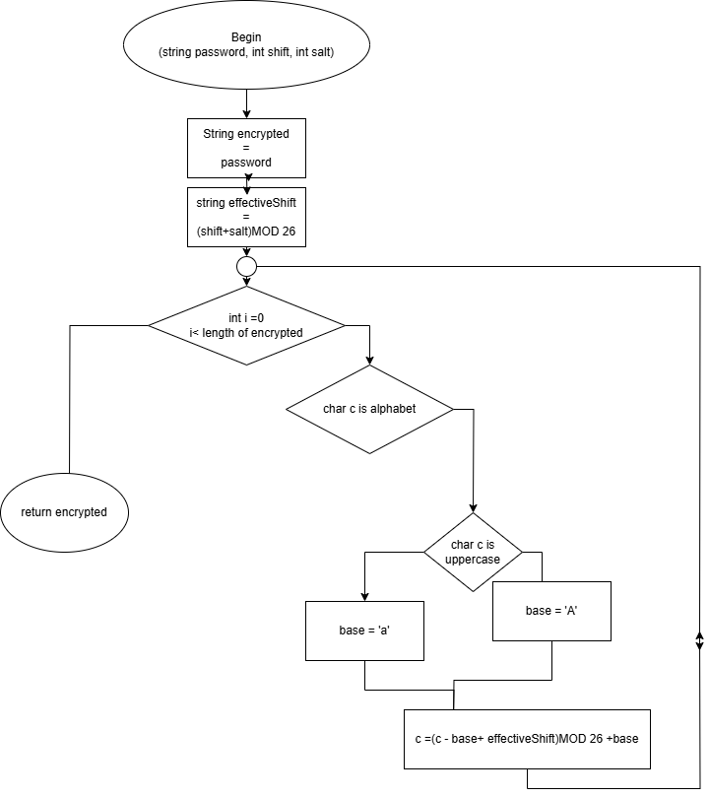

Salt Number Algorithm
